**Technical Support Fundamentals (IT5010)**

**Introduction:** our Company Name ‘Spring computers’ having its office in Wellington intends to extend our office site further to Auckland and two other. As an initial extension management advised to design a computer network solution for the new office in Auckland which should be compatible to fundamental concepts of IT Technical Support with a view of further development of two more offices.

**Requirements:** The design should consist of at least four computers, printer, a software tool to monitor and manage call logs, customer support and taking care of communication between sites are secured.

In addition, the design prioritisation system for handling support calls, the budget should not cross $20,000.

**Networking Topology Suggested : Ring Topology –** it is the best and simple .WE also use it in our school .A ring network is a network topology in which each node connects to exactly two other nodes, forming a single continuous pathway for signals through each node , with each node along the way handling every packet.

**Handling the support call prioritisation:** Range of factors to consider.

* **Problems:** Interruptions in service to customers.
* **Request:** Asking for services that are part of the HELP DESK’s advertised list of services.
* **Questions:** Queries about how to perform specific tasks using technology.
* **WORK ITEMS:** You have to be able to prioritise work planned and unplanned, against everything else going on in your Help Desk.
* **Help Desk:** Improvement or call elimination initiatives are usually carried out by the second level of support. If you are working on the second level of support, make sure you give call elimination work the priority it deserves.
* **Important :** Following the guidelines of ITSM ( IT SERVICE MANAGEMENT )prioritize the problem into categories of : 1. LOW

2 High

3 Medium and

4 CRITICAL

These categories will be incorporated into ticketing system of software purchased to manage and monitor call logs customer support.

* Sec**uring Communication Channel:**
* 1. Router having VPN.
* 2. Firewall having VPN.
* VPN – meaning virtual Private Networks. Security Networks are composed of 3 site: Collectively named – CIA.
* CONFIDENTIALITY: Critical confidential information of our organisation should not be exposed to any unauthorised person, whether it is within our organisation or outside personal in transit of data, but we have in place barriers to protect data and ensuring that information is always available 24/7 to the right recipient or recipients as and when required with utmost integrity.
* INTEGRITY: Data security is the practice of protecting digital information from unauthorised access, corruption or theft throughout its entire lifecycle. It’s a concept that encompasses every aspect of information security from the physical security of hardware and storage devices to administrative and access controls as well as the logical security of the software applications. It also includes organizational policies and procedures.
* **Availability:** Any critical or important data in transit should not be tampered or modified ensuring that data is available with utmost dignity and integrity.
* **Encryption: Using** an algorithm to transform normal text characters into an unreadable format, encryption keys scramble data so that only authorized users can read it. File and database encryption solutions serve a final line of defence
* For sensitive volumes by obscuring their contents through encryption. Most solutions also include security key management capabilities.

We can ensure complex passwords are made and available for executive’s and senior staff .They are made up of eight characters.eg,///…..

**Automated compliance reporting:** Comprehensive data protection solutions with automated reporting capabilities can provide a centralised repository for enterprise –wide compliance audit trails.

**Justification:** Everything is of utmost high quality, with warranty covering purchases .Secondly, there is a savings of almost $10.000, which could be used in further development of company’s use of facilities.

All components quotes from PB tech:

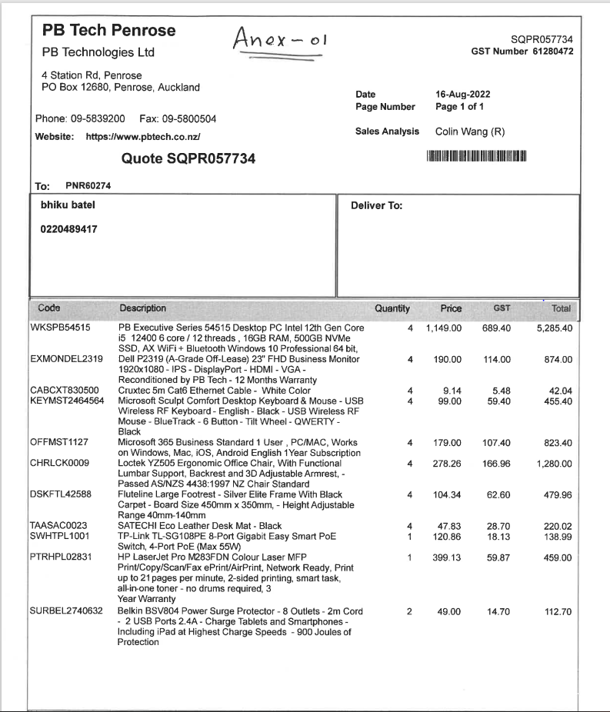

Network Diagram:

